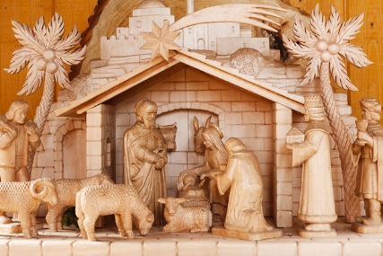
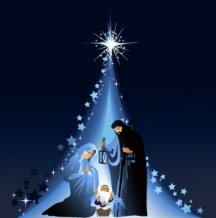
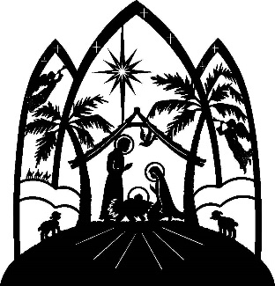

Christmas Masses Booking Form

To help us plan our Christmas Masses in line with Covid-19 precautions we are asking everyone attending to book a place at Mass.

There will be 4 Masses on Christmas Eve and Christmas Day.

Please indicate which Mass you wish to attend, 1 for first preference, 2 for second preference and so on, and the number in your household group. Only single households or support bubbles will be able to sit together under current rules.

Mass date and Time | Preference | Number in Household Group
Thursday 24th December 2020 5pm Vigil
Thursday 24th December 2020 8pm Vigil
Friday 25th December 2020 9-30 am
Friday 25th December 2020 11-30am

Name
Address
Telephone Number
Email

Signed ………………………………………………………….

Date ……………………………………………………………...

Please save the form with your details and return by email to:-

admin@stjosephsrcchurchstockport.org.uk

The data contained on this formed will only be used to contact you regarding your choice of Mass and for NHS track and trace purposes. It will be destroyed 21 days from the Mass you attend to comply with GDPR.

